PART 3: On AI Agent Integration

For this part I need to take artificial intelligence (AI) so that I will help me more on solving problems, refining logic and enhancing my documentation in the assignment. Here I am using Microsoft copilot.

1. I am making a automated pet feeder and this is my pseudocode. Review this and suggest improvements or identify potential issues.

**AI Response**: Copilot gave me response saying the system is well structured and overall covers the important components like feeding time schedule, motor control, weight sensor, alert sensor etc. It also gave me suggestion where I can improve for more reliability and clarity. It told me rather than comparing the direct time, but comparison should be check if the current time matches with any feeding scheduled. There are some typographical errors in variable names, and which should be corrected for consistency. It also suggested me to enhance the alert system with timestamps and feeding log to record what type of food was eaten and not eaten. Overall, my logic was good but there is always a room for betterment for more reliable and scalable.

1. Can you give me way to improve my flowchart logic?

**AI Response**: Copilot gave me ways to improve my flowchart logic and be more efficient, readable and robust. Use of modular block to break down the logic into clear modules. Use of decision block in comparing current time rather than a direct comparison. Replace my threshold-based sensor check and add decision block so that it helps in avoiding false alerts caused by sensor noise. Add a system health check and integrating remote monitoring. Manual feed request decision should be added.

1. How can my system be built using a actual hardware (e.g.: Arduino and Raspberry Pi)?

**AI Response**: It gave me 3 approach we can make system using actual hardware. We can make Arduino Based System, Raspberry Pi Based System and Hybrid Based approach. The components will be microcontroller, Real time clock, servo motor, weight sensor, alert system, storage and power supply. It also gave me pros and cons of the system.

Use of copilot really helped a lot. It helped me to refine my automated pet feeder system. I shared my pseudocode for the review and gave me some suggestion. It helped me understand more and how differently I can think of the logics used to create a system. I also asked suggestion to improve my flowchart which gave me where I am lacking and can improve so that system works properly. I also asked how we can create the system I made in real life using hardware’s and gave me proper explanation. So, it really helped me to understand the problem and how I can overcome those. Below I have also attached a screenshot of the ai response:

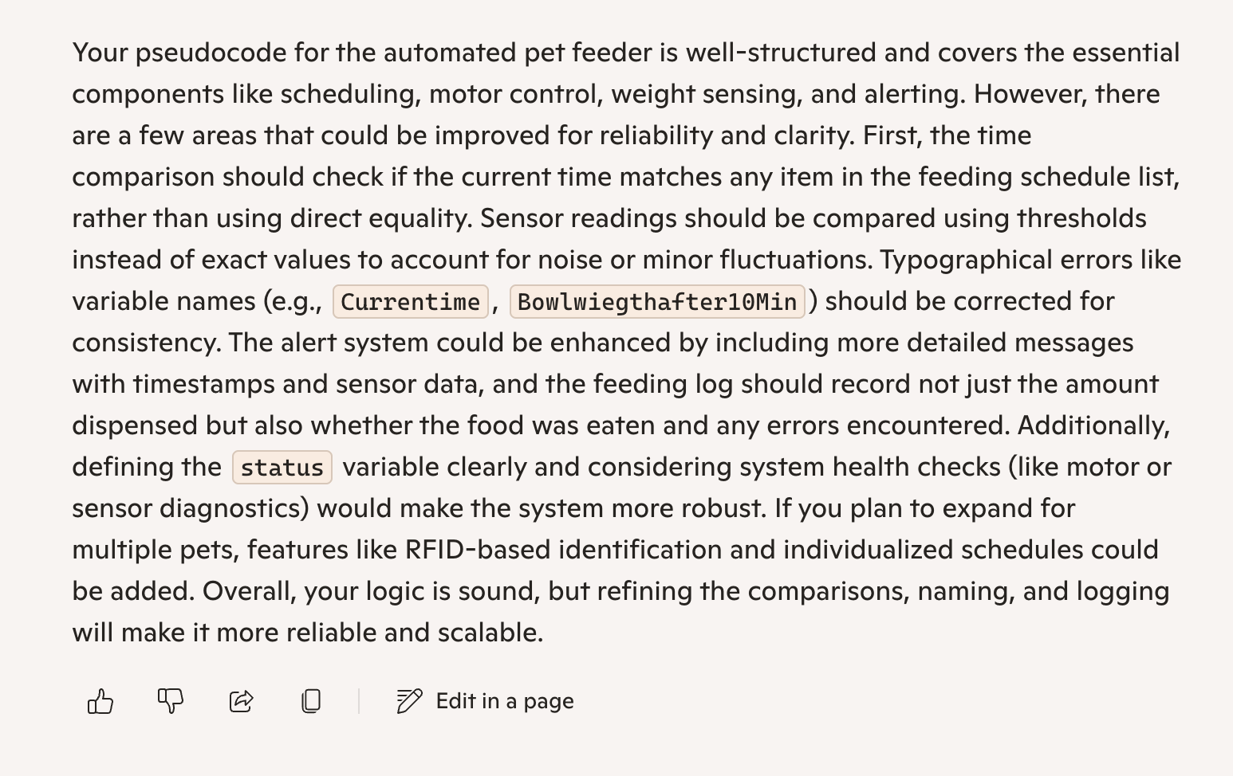

Fig: Screenshot of a copilot response.